Need to make ET and Recharge transient

Challenge: ET On and Off

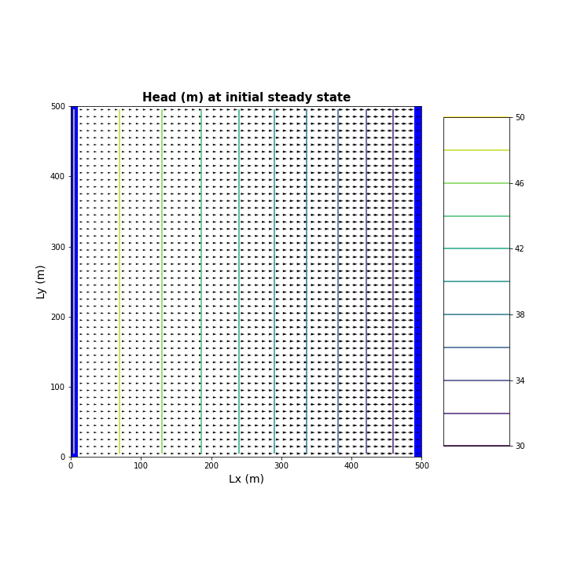**1.Plot the heads (or WTD) of the initial steady state condition. The gradient is not uniform for the initial steady state conditions - discuss the influences of recharge and the unconfined condition on this nonlinearity**

Answer: The cross-sectional area changes over time. The first graph shows our initial conditions, without anything happening.

**2.Determine if the system has reached steady state after 10 years - consider a point at the well and another at the center of the domain.**

Answers: Yes, it has reached steady state. You can have a system that is oscillating at a steady state. End is almost the same is called a dynamic equilibrium. The amount of water in the system is always the same at the end of the year (or every year).

**3. Repeat your run this time for 100 years and reconsider question 2 again.**

The system does reach a steady state after 100 years. It is the same oscillating steady state, a dynamic equilibrium. As we can see, our plot for our midpoint does not reach the same value as the initial head, which is the head in a steady state condition. For the head at the well, it also doesn’t reach the initial steady state head in this area. We can say it almost reaches a steady state but doesn’t make it all the way.

**4. Find the zone of influence of the well, defined in two ways: Based on the drawdown from the initial steady state to the end of simulation time (end of final no-pumping stress period). Based on the drawdown from the end of the last pump-on stress period to the end of simulation time.**

You see the influence of recharge in the first graph, nine months after pump was off (no zone of influence). You see the influence of just the pumping from the well in the second graph (cone of depression).